**Internship Documentation :**

**Company Name : Akash Technolab**

**Internship technology : PHP**

**Submitted By : Ronakbhai Bharatbhai Bhalala**

**Date : 31/05/21**

**Task 4 :**

**Practice :**

**Program 1 : Example of Numerical array**

<?php

//numerical Array

echo "<h1>Numerical Array</h1>";

//method 1

$a[0]=10;

$a[2]=120;

$a[3]=20.26;

$a[4]="r";

$a[5]="008";

//method 2 //index dynamic array

$a[]=10;

$a[]=20;

$a[]=20.50;

$a[]="Ronak";

$a[]="190163107008";

//method 3 use always

$a = array(10,20,30,"ronak","abhi",10.50);

// print array value

echo $a[3];

//print whole array

for($i=0;$i<count($a);$i++){

echo "<br/>".$a[$i];

}

//inbuilt array function to debug array

echo "<pre>";

print_r($a);

echo "<pre>";

echo "<pre>";

var_dump($a);

echo "<pre>";

?>

**Output:**

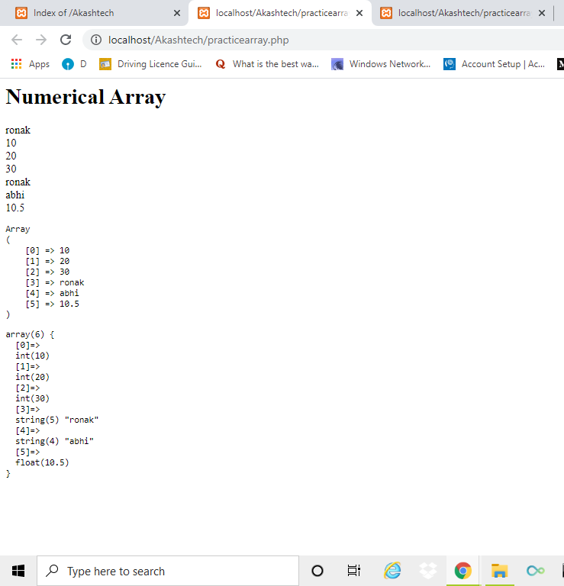

**Program 2 : Example of Associative array**

<?php

//Associative Array

//Key = value

echo "<h1>Associative Array</h1>";

//method 1

$a[0]=10;

$a["c"]="computer";

$a["php"]="Web developement";

$a[4]="four";

$a[5]=50.50;

//method 2

//method 2 use always this method TO CREATE array

$a = array(

0 => 10,

"c" => "Cat",

"php" => "Web",

10 => "ten",

50 => 50.10,

);

// print array value

echo "C for ".$a['c'];

//print whole array

foreach($a as $value){

echo "<br/>value is ".$value;

}

foreach($a as $key => $value){

echo "<br/>key is <b>$key</b> and value is <b>$value</b>";

}

//inbuilt array function to debug array

echo "<pre>";

print_r($a);

echo "<pre>";

echo "<pre>";

var_dump($a);

echo "<pre>";

?>

**Output:**

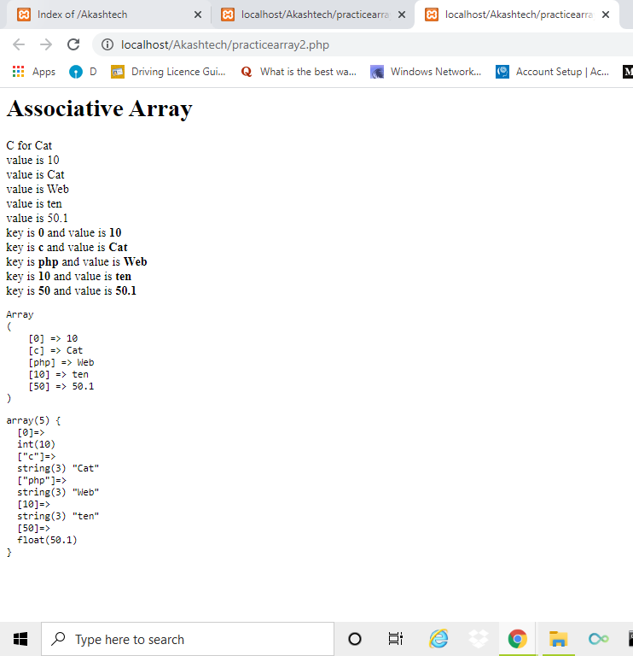

**Task 2 :**

**Code:-**

**1. Array Function.**

|  |
| --- |
|  |
| <?php |
|  |  | echo "<h2>Count Function</h2>"; |
|  |  | $arr = array('php','c','c++','java','Android'); |
|  |  | echo count($arr); |
|  |  |  |
|  |  | echo "<h2>Count Values Function</h2>"; |
|  |  | $arr = array("C","php","c","android","php","java"); |
|  |  | $newarr = array_count_values($arr); |
|  |  | foreach ($newarr as $key => $value) { |
|  |  | echo "<br/>$key - <strong>$value</strong> "; |
|  |  | } |
|  |  |  |
|  |  | echo "<h2>Sum Function</h2>"; |
|  |  | $myarray = array(1,2,3,4,5); |
|  |  | echo array_sum($myarray); |
|  |  |  |
|  |  | echo "<h2>Product Function</h2>"; |
|  |  | $myarray = array(1,2,3,4,5); |
|  |  | echo array_product($myarray); |
|  |  |  |
|  |  | echo "<h2>Reverse Function</h2>"; |
|  |  | $arr = array('c', 'c++', 'java', 'android', 'php'); |
|  |  | $revarr = array_reverse($arr); |
|  |  | print_r($revarr); |
|  |  |  |
|  |  | echo "<h2>In Array Function</h2>"; |
|  |  | $arr = array('c', 'c++', 'java', 'android', 'php'); |
|  |  | $temp = in_array('php',$arr); |
|  |  | echo $temp; |
|  |  |  |
|  |  | echo "<h2>Random Function</h2>"; |
|  |  | $arr = array('c', 'c++', 'java', 'android', 'php'); |
|  |  | $indexofarray = array_rand($arr); //Returns Array Index |
|  |  | echo $arr[$indexofarray]; |
|  |  |  |
|  |  | echo "<h2>Multiple Keys at Random Function</h2>"; |
|  |  | $arr = array('c', 'c++', 'java', 'android', 'php'); |
|  |  | $indexofarray = array_rand($arr,2);//Returns Array Index |
|  |  | foreach ($indexofarray as $key => $value) |
|  |  | { |
|  |  | echo "<br />$key - <strong>" . $arr[$value] . "</strong>"; |
|  |  | } |
|  |  |  |
|  |  | echo "<h2>Unique Function</h2>"; |
|  |  | $arr = array('c', 'c++','android', 'java', 'android', 'php'); |
|  |  | print_r(array_unique($arr)); |
|  |  |  |
|  |  | echo "<h2>Merge Function</h2>"; |
|  |  | $arr1 = array('c','c++','android','java','php'); |
|  |  | $arr2 = array(10,20,30,40,50); |
|  |  | $NewArr = array_merge($arr1,$arr2); |
|  |  | print_r($NewArr); |
|  |  |  |
|  |  | echo "<h2>Search Function</h2>"; |
|  |  | $myarr = array('c', 'c++','android', 'java', 'php'); |
|  |  | $check = array_search('android', $myarr); |
|  |  | echo $check; // Return Index |
|  |  |  |
|  |  | echo "<h2>Range Function</h2>"; |
|  |  | $arr = range("11", "20"); |
|  |  | foreach($arr as $key => $value) |
|  |  | { |
|  |  | echo "<br /> $key - $value "; |
|  |  | } |
|  |  |  |
|  |  | echo "<h2>Sort Function</h2>"; |
|  |  | $arr = array(80,60,50,40,8,74); |
|  |  | sort($arr); |
|  |  | print_r($arr); |
|  |  |  |
|  |  | echo "<h2>RSort Function</h2>"; |
|  |  | $arr = array(80,60,50,40,8,74); |
|  |  | rsort($arr); |
|  |  | print_r($arr); |
|  |  |  |
|  |  | echo "<h2>ASort Function</h2>"; |
|  |  | $arr = array(80,60,50,40,8,74); |
|  |  | asort($arr); |
|  |  | print_r($arr); |
|  |  |  |
|  |  | echo "<h2>KSort Function</h2>"; |
|  |  | $arr = array( |
|  |  | "Banana" => "Yellow", "Apple" => "Red", |
|  |  | "Mango" => "Green" |
|  |  | ); |
|  |  | ksort($arr); |
|  |  | foreach ($arr as $key => $value) |
|  |  | { |
|  |  | echo "<br />$key - $value "; |
|  |  | } |
|  |  |  |
|  |  | echo "<h2>KSort Reverse Function</h2>"; |
|  |  | $arr = array( |
|  |  | "Banana" => "Yellow", "Apple" => "Red", |
|  |  | "Mango" => "Green" |
|  |  | ); |
|  |  | krsort($arr); |
|  |  | foreach ($arr as $key => $value) { |
|  |  | echo "<br />$key - $value "; |
|  |  | } |
|  |  |  |
|  |  | echo "<h2>Shuffle Function</h2>"; |
|  |  | $myArray = array("Football", "Baseball", "Hockey", "Tennis", "Boxing"); |
|  |  | shuffle($myArray); // Shuffle the array |
|  |  | foreach ($myArray as $key => $value) { |
|  |  | echo "<br /> $value "; |
|  |  | } |
|  |  |  |
|  |  | echo "<h2>Key Exists Function</h2>"; |
|  |  | $arr = array("a" => "apple", "b" => "banana"); |
|  |  | echo array_key_exists('a',$arr); |
|  |  |  |
|  |  | echo "<h2>Change Key Case Function</h2>"; |
|  |  | $arr = array( |
|  |  | "Banana" => "Yellow", |
|  |  | "Apple" => "Red", |
|  |  | "Mango" => "Green" |
|  |  | ); |
|  |  | $uppercase = array_change_key_case($arr,CASE_UPPER); |
|  |  | print_r($uppercase); |
|  |  |  |
|  |  | echo "<h2>Combine Function</h2>"; |
|  |  | $arr1 = array("Banana" , "Apple" , "Mango"); |
|  |  | $arr2 = array("Yellow","Red", "Green"); |
|  |  | $NewVar = array_combine($arr1, $arr2); |
|  |  | print_r($NewVar); |
|  |  |  |
|  |  | echo "<h2>End Function</h2>"; |
|  |  | $myarr = array('c', 'c++','android', 'java', 'php'); |
|  |  | echo end($myarr); |
|  |  |  |
|  |  | echo "<h2>Compact Function</h2>"; |
|  |  | $name = "Ayush"; |
|  |  | $subject = "php"; |
|  |  | $arr = compact("name", "subject"); |
|  |  | print_r($arr); |
|  |  |  |
|  |  | echo "<h2>Flip Function</h2>"; |
|  |  | $arr = array("a" => "ayush", "b" => "banana", "c" => "computer"); |
|  |  | $fliparray = array_flip($arr); |
|  |  | print_r($fliparray); |
|  |  |  |
|  |  | echo "<h2>Difference Function</h2>"; |
|  |  | $a=array("Ayush","c","c++","java","php","android"); |
|  |  | $b=array("Ayush","c","java","php"); |
|  |  | $diff = array_diff($a, $b); print_r($diff); |
|  |  |  |
|  |  | echo "<h2>Intersect Function</h2>"; |
|  |  | $arr1 = array(0=>"Sunday",1=>"Monday",2=>"Tuesday"); |
|  |  | $arr2 = array(3=>"Tuesday",4=>"Sunday",5=>"Thursday"); |
|  |  | print_r(array_intersect($arr1,$arr2)); |
|  |  |  |
|  |  | echo "<h2>Values Function</h2>"; |
|  |  | $arr = array("i"=>"c","want"=>"c++","learn"=>"php"); |
|  |  | $myarr = array_values($arr); |
|  |  | foreach($myarr as $key => $value) { |
|  |  | echo " <br />$key - $value"; |
|  |  | } |
|  |  |  |
|  |  | echo "<h2>Push Function</h2>"; |
|  |  | $a=array("c","c++"); |
|  |  | array_push($a,"java","php"); |
|  |  | print_r($a); |
|  |  |  |
|  |  | echo "<h2>Pop Function</h2>"; |
|  |  | $a = array("c", "c++", "Java", "PHP", "ASP"); |
|  |  | array_pop($a); //Remove |
|  |  | print_r($a); |
|  |  | array_pop($a); //Remove |
|  |  | print_r($a); |
|  |  |  |
|  |  | echo "<h2>Explode Function</h2>"; |
|  |  | $mystring = "I Love PHP Language"; |
|  |  | $arr = explode(" ",$mystring); |
|  |  | print_r($arr); |
|  |  |  |
|  |  | echo "<h2>Implode Function</h2>"; |
|  |  | $arr = array("i","love","php","language"); |
|  |  | $mystring = implode(" ", $arr); |
|  |  | echo $mystring; |
|  |  |  |
|  |  |  |

?>

**Output:**

